**Supporting Information**

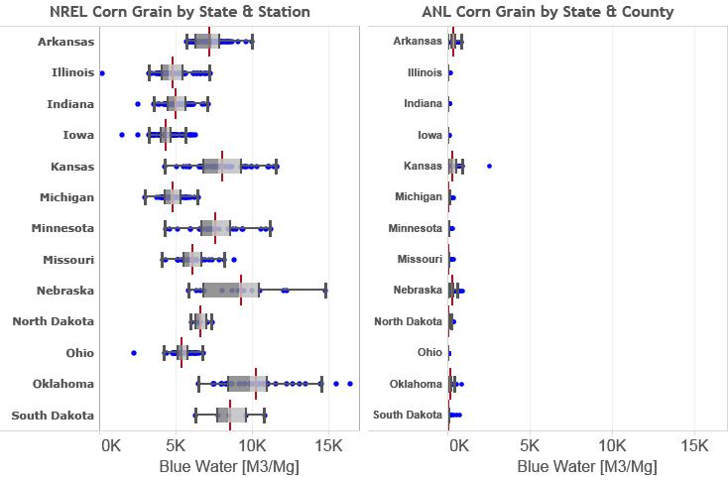

**Frame A**

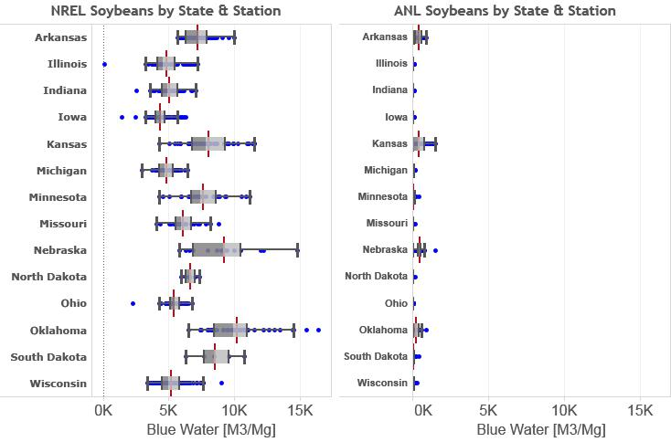

**Frame B**

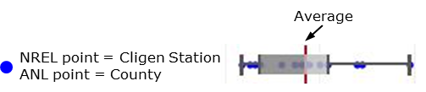

**Figure 7.** Corn grain (frame A) and soybean (frame B) green water use by state. Green dots represent stations in the NREL data and county average in the ANL data. Box and whisker plots represent the average value along with the 2.5th, 25th, 50th, 75th, and 90th percentiles. NREL blue water use data represents maximum blue water use to get “full yields”. ANL data is based on USDA survey data.(61)